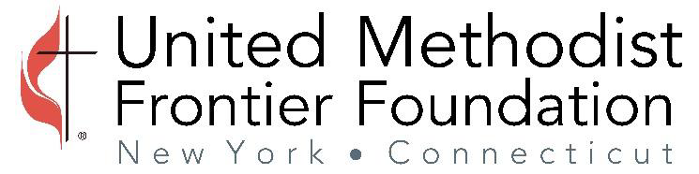

20 Soundview Ave, White Plains, N.Y. 10606
914-615-2239

ACH Authorization Form

I (We) hereby authorize the United Methodist Frontier Foundation (“UMFF”) to initiate credit entries and, if necessary, debit entries and adjustments for any credit entry in error to the account and financial institution indicated below.

This authority will remain in effect until UMFF receives written notice to terminate such instructions.

Financial Institution Name:

Financial Institution Address:
Street address:

City, State, Zip:

Financial Institution Routing Number:
(nine digits)

Bank Account Name:

Bank Account Number:

Account Type: Checking Savings

Signature of Authorized person: _____________________________ Date:
(typed signatures are not acceptable)

Title of Authorized person:

Submit this form with an original signature and copy of voided check using the address at the top of the page, via email to mpalumberi@umff.org or via fax to 914-401-0661 “Attn: Maureen”.

